Name: Sumaiya Khan

ID-1921173042

Section 1 lab

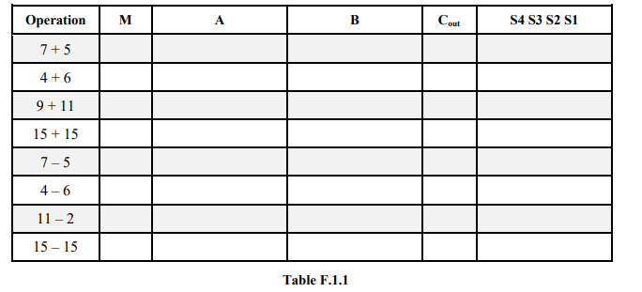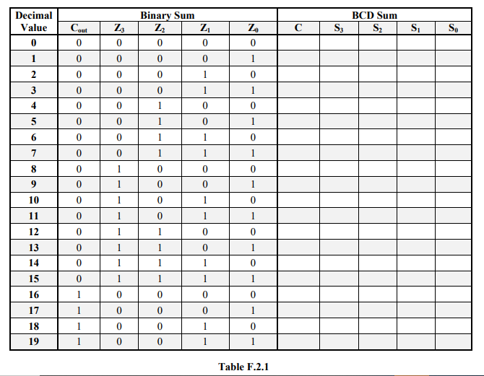

0

0

0

0

1

1

1

1

0111 0101 1100

0100 0110 1010

1001 1011 1 0100

1111 1111 1 1110

0111 0101 1 0010

0100 0110 1110

1011 0010 1 1001

1111 1111 1 0000

0 0 0 0

0 0 0 1

0 0 1 0

0 0 1 1

0 1 0 0

0 1 0 1

0 1 1 0

0 1 1 1

1 0 0 0

1 0 0 1

1 0 0 1 0

1 0 0 1 1

1 0 0 1 0

1 0 0 1 1

1 0 1 0 0

1 0 1 0 1

1 0 1 1 0

1 0 1 1 1

1 0 1 0 0

1 1 0 0 1

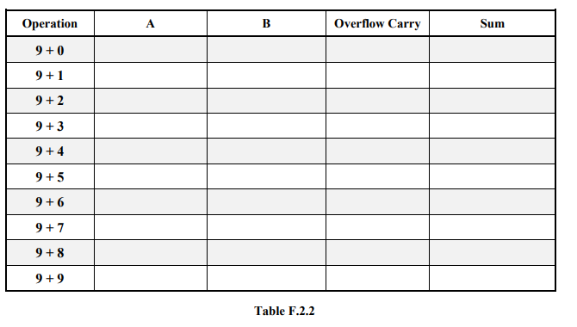

1001 0000 1001

1001 0001 1 0000

1001 0010 1 1000

1001 0011 1 0010

1001 0100 1 0011

1001 0101 1 0100

1001 0110 1 0101

1001 0111 1 0110

1001 1000 1 0111

1001 1001 1 1000

1001 0000 1001

1001 0000 1001

1001 0000 1001